CS 1500 Assignment, Week 8+9

# Part I: Required Readings and Lecture Content

* Watch the videos here for the lectures.

Video Lecture 1, Week 8+9 Update: <https://youtu.be/gHMsSK-QsFQ>

Video Lecture 2, Chapter 13, part 1: <http://bit.ly/2HJa4bN>

Video Lecture 3, Chapter 13, part 2: <https://youtu.be/Oo7C2kwkYpc>

Video Lecture 4, Chapter 13, part 3: <https://youtu.be/UfxH3XXEvkw>

Video Lecture 5, Chapter 13, part 4: <https://youtu.be/7p-Xdod10Kc>

* Read and be familiar with chapter 13 of Blum & Bresnahan.

# Part 2: Chapter 13, Loops (1)

Type in and run the following scripts from the text, chapter 13:dir

* test6 (p. 339, for-each loop--of course, use your own home directory in the variable, not the author’s)

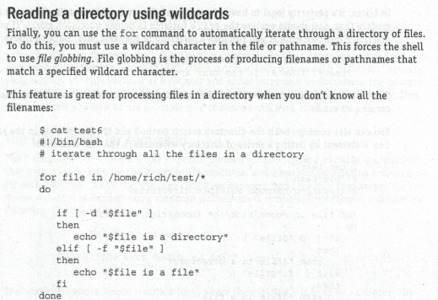

Output of test6:

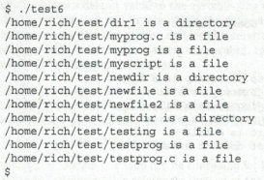

* test9 (p. 342, C-style for-loop with multiple variables)

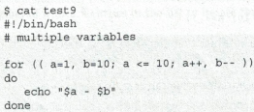

Output of test9:





* test10 (p. 343, while loops)



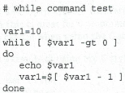

Output of test10:

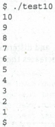

Use the cat command to display content of all three scripts, run all three scripts, and capture that part of the terminal interactions below.

>>>>>Paste your terminal capture below this line >>>>>

**andrew@andrew-VirtualBox**:**/home**$ cat test6.sh

#!/bin/bash

for file in /home/*

do

if [ -d "$file" ]

then

echo "$file is a directory"

elif [ -f "$file" ]

then

echo "$file is a file"

fi

done

**andrew@andrew-VirtualBox**:**/home**$ ./test6.sh

/home/andrew is a directory

/home/koenigtest is a directory

/home/scriptdirectory is a directory

/home/scripts_hw is a directory

/home/test10 is a file

/home/test6.sh is a file

/home/test9 is a file

/home/test-conditions.sh is a file

**andrew@andrew-VirtualBox**:**/home**$ cat test9

#!/bin/bash

for (( a=1, b=10; a<=10; a++, b-- ))

do

echo "$a - $b"

done

**andrew@andrew-VirtualBox**:**/home**$ ./test9

1 - 10

2 - 9

3 - 8

4 - 7

5 - 6

6 - 5

7 - 4

8 - 3

9 - 2

10 - 1

**andrew@andrew-VirtualBox**:**/home**$ cat test10

#!/bin/bash

var1=10

while [ $var1 -gt 0 ]

do

    echo $var1

    var1=$ [ $var1 - 1 ]

done

**andrew@andrew-VirtualBox**:**/home**$ ./test10

10

./test10: line 7: [: -: binary operator expected

10

./test10: line 7: [: -: binary operator expected

10

./test10: line 7: [: -: binary operator expected

10

./test10: line 7: [: -: binary operator expected

10

./test10: line 7: [: -: binary operator expected

10

<<<<< Paste your terminal capture above this line <<<<<

# Part 3: Chapter 13, Loops (2)

Create a script (in your $HOME/script directory) called week7Assn1. The script should:

* Check to see if the directory $HOME/week7Assn1 exists. If it does, delete it and any contents.
* Then, create the directory (empty).
* Then, using a C-style for-loop, create ten files named file-0, file-1, ..., file-9 (using touch) within the $HOME/week7Assn1 directory.
* Then, provide a listing of $HOME/week7Assn1.

A test run of my script is shown below:

trang@trang-VirtualBox ~/scripts $ week7Assn1

Deleting existing directory /home/trang/week7Assn1 and all contents...done

Creating empty /home/trang/week7Assn1...done.

Listing of /home/trang/week7Assn1:

Creating ten files...done.

Listing of /home/trang/week7Assn1:

file-0    file-1 file-2    file-3 file-4 file-5    file-6 file-7 file-8 file-9

trang@trang-VirtualBox ~/scripts $

Use the command cat week7Assn1, then run week7Assn1, and capture that part of the terminal interactions below.

>>>>>Paste your terminal capture below this line >>>>>

**andrew@andrew-VirtualBox**:**/home/scriptdirectory**$ cat week7assn1

#!/bin/bash

dir="/home/scriptdirectory/week7assn1.sh"

if [ -e $dir ]

then

   echo "Deleting existing directory $dir and all contents...done"

   rm -rf $dir

fi

echo "Creating empty ${dir}...done."

mkdir $dir

echo "Listing of $dir:"

for i in {0..10}

do

   touch $dir/"file-"$i

done

echo "Creating ten files...done."

echo "Listing of $dir:"

ls $dir

**andrew@andrew-VirtualBox**:**/home/scriptdirectory**$ sudo ./week7assn1

Deleting existing directory /home/scriptdirectory/week7assn1.sh and all contents...done

Creating empty /home/scriptdirectory/week7assn1.sh...done.

Listing of /home/scriptdirectory/week7assn1.sh:

Creating ten files...done.

Listing of /home/scriptdirectory/week7assn1.sh:

file-0 file-10  file-3  file-5  file-7  file-9

file-1 file-2 file-4  file-6  file-8

**andrew@andrew-VirtualBox**:**/home/scriptdirectory**$

<<<<< Paste your terminal capture above this line <<<<<

# Part 4: Submit your assignment to Blackboard

***NB. Don’t forget to take the weekly quiz!***

# Rubric: 50 points

* Part 2: test6, test9, test10, 30 points (10 each)
* Part 3: week7Assn1 script, 20 points
  + Accurate output, 10 points;
  + Follows instructions including use of for-loop, 10 points.

Maximum of 2 points deduction per mistake due to grader’s judgement.